
Computer Networks Lab
CSC319(Fall-2025/M-25567)

Smart Hotel Network

Group Members:
Areej Mazhar (20231-34638)
Muneeba Shoukat (20231-35056)
Rafay Khan (20231-34594)
Somil (20231-34062)

Instructor:
Taha Shaikh

Table of Contents
1. Introduction 3
1.1. Background 3
1.2. Project Overview 3
1.3. Scope of Project 3
2. Objectives 4
2.1. Functional Objectives 4
2.2. Security Objectives 4
3. Network Design 5
3.1. Overall Topology Description 5
3.2. Logical Network Layout 6
3.3. Departmental Segmentation 6
3.4. Devices Used and Their Roles 8
3.5. External ISP Network 9
4. IP Addressing Scheme 9
4.1. Addressing Strategy 9
4.2. VLAN-wise Subnet Allocation 10
4.3. Gateway Assignment 10
4.4. Static vs Dynamic IP Allocation 11
5. Network Configuration 18
5.1. VLAN Configuration on Switch 18
5.2. Trunk Configuration 19
5.3. Inter-VLAN Routing (Router-on-a-Stick) 20
5.4. Routing Protocol Configuration 21
5.5. Static Routing as Backup 22
6. Security Implementation 23
6.1. VLAN-Based Isolation 23
6.2. Access Control Lists (ACLs) 23
6.3. Network Address Translation (NAT) 25
6.4. DNS Configuration 27
7. Results and Testing 28
7.1. Connectivity Testing 28
7.2. NAT Verification 29
7.3. ACL Verification 30
7.4. DNS Verification 31
8. Conclusion 33
8.1. Summary of Implementation 33
8.2. Limitations 33
8.3. Future Improvements 34

1. Introduction

1.1. Background
With the increasing reliance on networked services in modern hotels, robust and secure computer networks have become essential for daily operations. Hotels must support a wide range of users, including guests, administrative staff, management, and security personnel, each with different access requirements. Providing internet access to guests while protecting internal systems from unauthorized access presents a significant networking challenge.
To address these requirements, enterprise networking technologies such as network segmentation, dynamic routing, and access control mechanisms are commonly used. Virtual Local Area Networks (VLANs) allow logical separation of network traffic, improving security and performance. Dynamic routing protocols like Open Shortest Path First (OSPF) enable scalable and efficient communication between internal networks and external service providers. These technologies form the foundation of modern smart hotel network infrastructures.

1.2. Project Overview
This project involves the design and simulation of a basic smart hotel networking system that demonstrates key enterprise networking concepts. The hotel network is segmented into five VLANs, each representing a different functional area of the hotel, including guest rooms, staff offices, management, security, and server infrastructure.
A central hotel router is used to manage inter-VLAN routing and provide connectivity to an Internet Service Provider (ISP). The routing between the hotel network and the ISP is implemented using a multi-area OSPF configuration, reflecting real-world routing practices. To simplify host configuration, DHCP is deployed to dynamically assign IP addresses to devices within each VLAN.
Security is enforced using Access Control Lists (ACLs) to restrict guest access to internal hotel resources while allowing unrestricted internet connectivity. Additionally, Dynamic Network Address Translation (NAT) is configured on the hotel router to enable private internal addresses to access external networks securely.

1.3. Scope of Project
The scope of this project is limited to the logical design, configuration, and simulation of a smart hotel network within a controlled lab environment. The project focuses on implementing core networking features such as VLAN segmentation, dynamic routing with OSPF, DHCP, NAT, and ACL-based security policies.
Physical infrastructure considerations, such as cabling standards, hardware performance optimization, redundancy, and real-world deployment constraints, are outside the scope of this project. Advanced security mechanisms such as intrusion detection systems (IDS), firewalls beyond basic ACLs, and wireless security enhancements are also not covered.
The project aims to demonstrate a functional and secure network design that meets the basic operational and security requirements of a hotel environment while reinforcing fundamental networking concepts taught in the computer networks laboratory.

2. Objectives

2.1. Functional Objectives
The functional objectives of this project focus on ensuring reliable network operation, efficient communication, and proper resource management within the smart hotel environment. These objectives include:
- To design and implement a hotel network segmented into multiple VLANs, each representing a specific department or user group.
- To enable inter-VLAN routing through a centralized hotel router to allow controlled communication between network segments.
- To implement multi-area OSPF routing between the hotel network and the ISP to ensure scalable and dynamic route exchange.
- To configure DHCP services to automatically assign IP addresses to end devices across different VLANs.
- To provide seamless internet connectivity to all authorized users within the hotel network.
- To verify network functionality through connectivity testing and simulation-based validation.

2.2. Security Objectives
The security objectives aim to protect internal hotel resources while maintaining appropriate access for different user groups. These objectives include:
- To restrict guest network access to internal hotel systems such as staff, management, security, and server networks.
- To implement Access Control Lists (ACLs) that enforce network access policies based on VLAN and IP addressing.
- To allow guest users internet-only access without exposing internal private networks.
- To configure Dynamic Network Address Translation (NAT) on the hotel router to conceal internal IP addressing and enable secure external communication.
- To ensure logical isolation between VLANs to reduce the risk of unauthorized access and network misuse.

3. Network Design

3.1. Overall Topology Description
The Smart Hotel Network is designed using a hierarchical topology to ensure scalability, manageability, and security. The network is divided into an internal hotel network and an external ISP network, interconnected through routing and NAT.
A central Hotel_Router functions as the core device, providing inter-VLAN routing, DHCP services, and internal network control. A managed Hotel_Switch is used to connect all end devices and logically separate departments using VLANs.
An ISP_Router, connected to an ISP_Switch and ISP_Server, simulates external internet connectivity and demonstrates Network Address Translation (NAT).
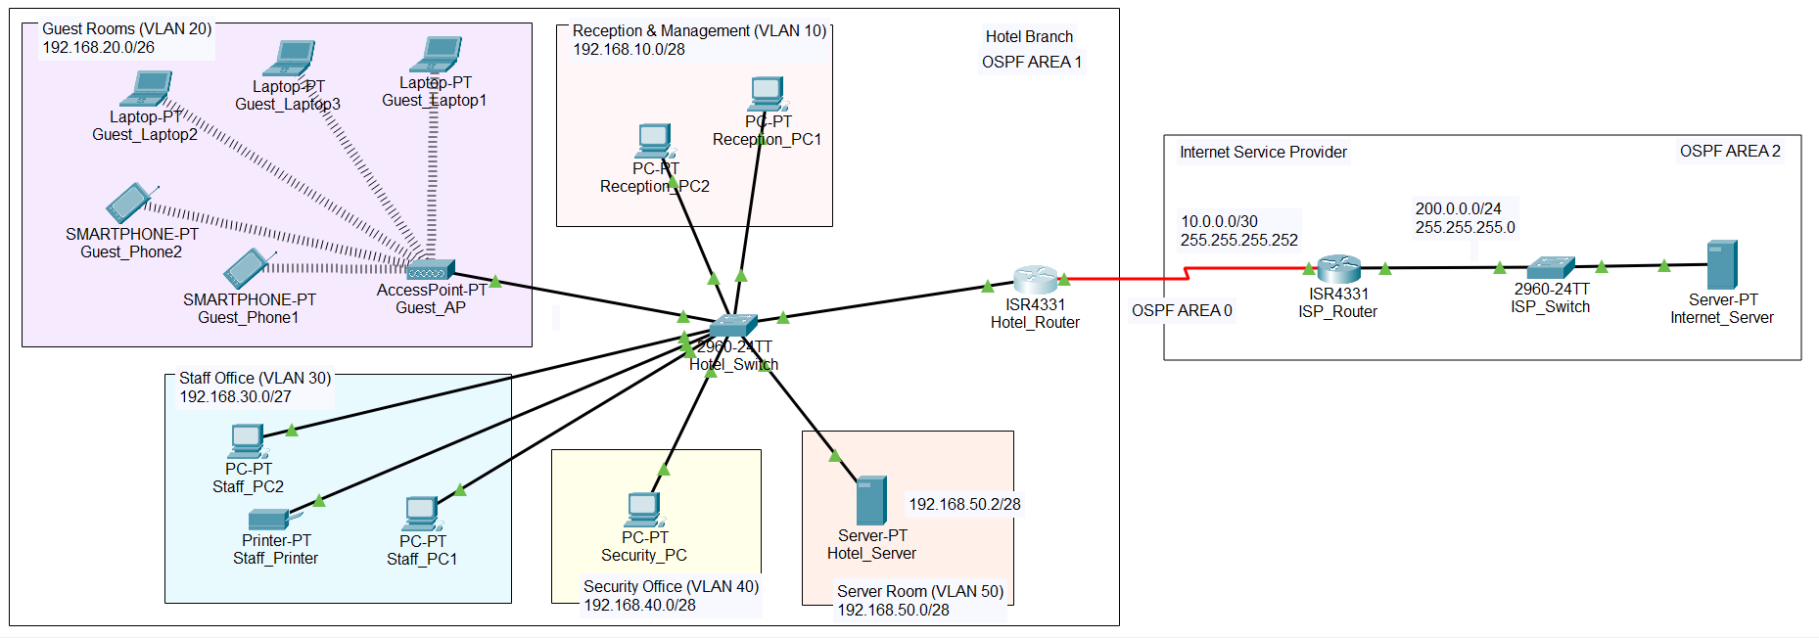

3.2. Logical Network Layout
The logical layout of the network is based on VLAN-based segmentation, where each department operates within its own isolated broadcast domain. Although all devices are physically connected to the same Hotel_Switch, VLANs ensure logical separation at the data link layer.
Inter-VLAN communication is achieved using router-on-a-stick, where the Hotel_Router uses multiple sub-interfaces configured with IEEE 802.1Q encapsulation. Each sub-interface serves as the default gateway for its respective VLAN.
The Guests VLAN includes both wired and wireless components, where a dedicated access point provides connectivity to mobile devices such as laptops and smartphones.

3.3. Departmental Segmentation
The hotel network is divided into multiple departments, each assigned a dedicated VLAN to enhance security, reduce broadcast traffic, and simplify management. This segmentation ensures that sensitive departments such as staff, security, and servers are isolated from guest traffic.
- Reception VLAN (VLAN 10):
Contains two receptionist PCs responsible for front-desk operations.
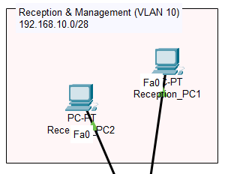

- Guests VLAN (VLAN 20):
Includes one wireless access point connected to three laptops and two smartphones, simulating hotel guest Wi-Fi access.
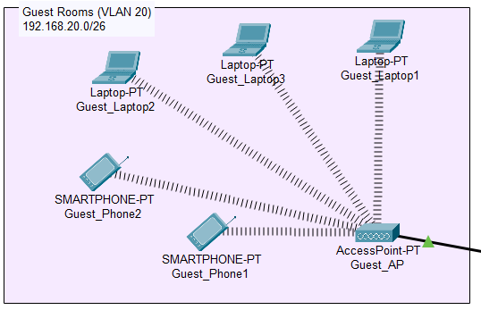
- Staff VLAN (VLAN 30):
Consists of two staff PCs and one network printer, supporting internal administrative tasks
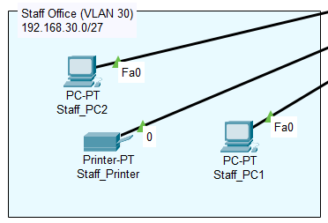

- Security VLAN (VLAN 40):
Contains a single security PC used for monitoring and security-related operations.
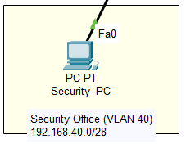
- Servers VLAN (VLAN 50):
Hosts the Hotel_Server, which provides internal network services.
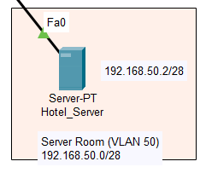

3.4. Devices Used and Their Roles
The following devices are used in the Smart Hotel Network, each serving a specific role:
- Hotel_Router:
Acts as the central routing device. It performs inter-VLAN routing, runs OSPF, provides DHCP services, and forwards traffic towards the ISP network.
- Hotel_Switch:
Connects all internal hotel devices and enforces VLAN-based segmentation. The switch-router link operates as a trunk to carry multiple VLANs.
- Wireless Access Point (AP):
Provides wireless connectivity to guest devices and is assigned to the Guests VLAN.
- Hotel_Server:
Hosts internal services such as DNS and is assigned a static IP address for reliable access.
- End Devices (PCs, Laptops, Smartphones, Printer):
Represent users and operational equipment within different departments. Most devices obtain IP addresses dynamically via DHCP.
- ISP_Router:
Represents an external service provider and performs NAT to allow internal private networks to access external resources.
- ISP_Switch and ISP_Server:
Simulate an external network and server reachable from the hotel network.

3.5. External ISP Network
The external network is simulated using an ISP_Router, ISP_Switch, and ISP_Server to represent internet connectivity. This network is logically and physically separated from the internal hotel network.
The Hotel_Router connects to the ISP_Router through a routed link. Network Address Translation (NAT) is implemented at the ISP-facing interface to allow internal private IP addresses to communicate with the external server. This design demonstrates controlled external access while maintaining internal network security.

4. IP Addressing Scheme

4.1. Addressing Strategy
The Smart Hotel Network uses private IPv4 addressing with custom CIDR blocks assigned to each VLAN based on departmental size and requirements. Instead of using a single large subnet, smaller subnets were allocated to improve address utilization and reduce unnecessary broadcast traffic.
Although traditional VLSM is typically applied within a single major network, VLSM principles were applied conceptually in this design by assigning different subnet sizes to different VLANs according to their expected number of hosts. Separate third-octet networks were used for each VLAN to avoid IP overlap limitations within Cisco Packet Tracer.
This approach provides clarity, scalability, and ease of troubleshooting while still demonstrating efficient subnet planning.

4.2. VLAN-wise Subnet Allocation
Each VLAN is assigned a unique subnet with an appropriate subnet mask based on the number of devices in that department.

VLAN | Department | Subnet | Subnet Mask | Network Address | Usable IPs | Gateway | Block Size
10 | Reception | /28 | 255.255.255.240 | 192.168.10.0 | 192.168.10.1–14 | 192.168.10.1 | 16
20 | Guests | /26 | 255.255.255.192 | 192.168.20.0 | 192.168.20.1–62 | 192.168.20.1 | 64
30 | Staff | /27 | 255.255.255.224 | 192.168.30.0 | 192.168.30.1–30 | 192.168.30.1 | 32
40 | Security | /28 | 255.255.255.240 | 192.168.40.0 | 192.168.40.1–14 | 192.168.40.1 | 16
50 | Servers | /28 | 255.255.255.240 | 192.168.50.0 | 192.168.50.1–14 | 192.168.50.1 | 16
The Guests VLAN was allocated the largest subnet due to the higher number of expected devices, while smaller departments were assigned smaller subnets.

4.3. Gateway Assignment
Each VLAN uses a router sub-interface on the Hotel_Router as its default gateway. The router-on-a-stick approach allows a single physical router interface to handle traffic from multiple VLANs using IEEE 802.1Q encapsulation.
The first usable IP address of each subnet was assigned to the corresponding router sub-interface, ensuring consistent and easily identifiable gateway addresses across all VLANs.
This design enables controlled inter-VLAN routing while maintaining logical separation between departments.
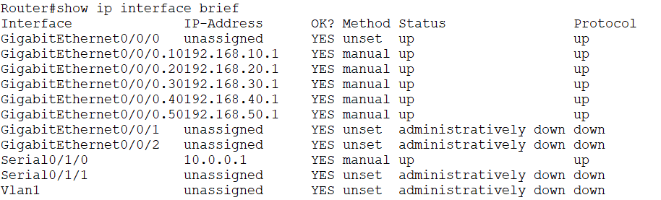

4.4. Static vs Dynamic IP Allocation
To balance flexibility and stability, the network uses both dynamic and static IP addressing.

Dynamic IP Allocation (DHCP)
Dynamic Host Configuration Protocol (DHCP) is used to automatically assign IP addresses to end-user devices across all VLANs. Separate DHCP pools were configured for each VLAN on the Hotel_Router, ensuring that devices receive IP addresses, subnet masks, default gateways, and DNS information appropriate to their department.
This reduces manual configuration effort and allows devices to join or leave the network seamlessly.
Planning table:
VLAN | DHCP Range | Gateway | Notes
10 RECEPTION | 192.168.10.2–14 | 192.168.10.1 | Router is 10.1
20 GUESTS | 192.168.20.2–62 | 192.168.20.1 | Router is 20.1
30 STAFF | 192.168.30.3–30 | 192.168.30.1 | Only Printer static IP 192.168.30.2
40 SECURITY | 192.168.40.2–14 | 192.168.40.1 | Router is 40.1
50 SERVERS | none | 192.168.50.1 | Only static IP 192.168.50.2

VLAN 10 DHCP (Reception_Pool):
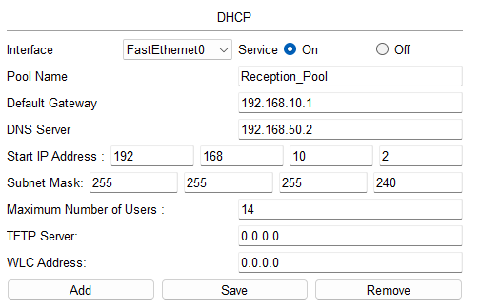
In VLAN 10 (Reception_PC1)
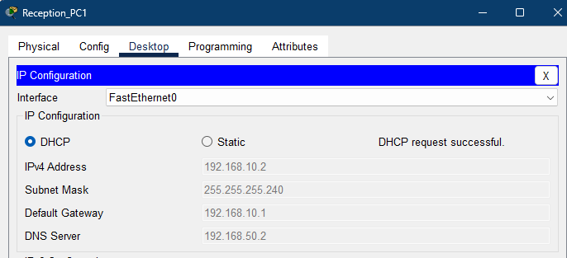
VLAN 20 DHCP (Guest_Pool)
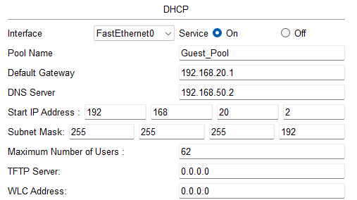
In VLAN 20 (Guest_Laptop3)
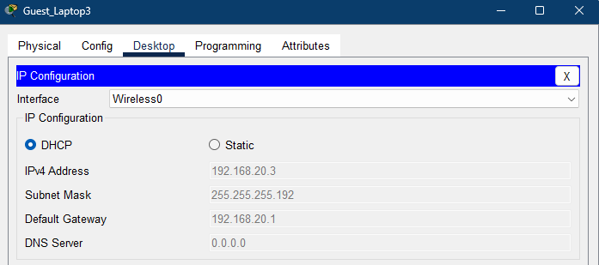
VLAN 30 DHCP (Staff_Pool)
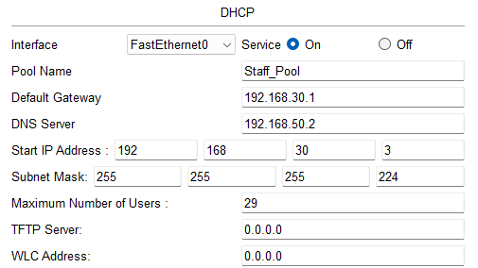
In VLAN 30 (Staff_PC1)
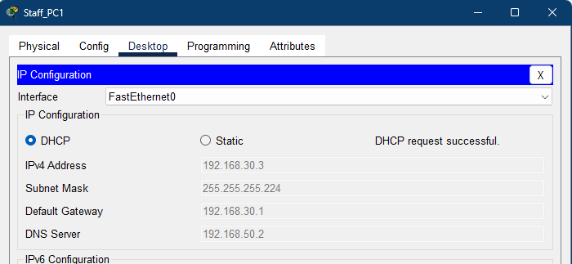
VLAN 40 DHCP (Security_Pool)
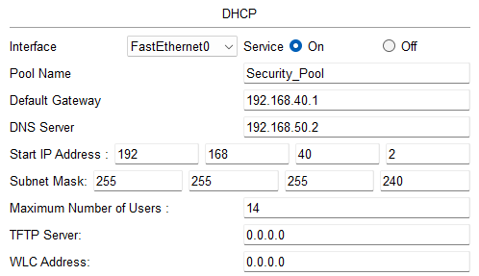
In VLAN 40 (Security_PC)
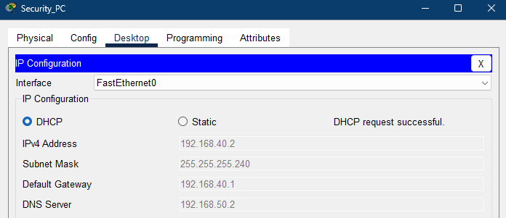

Static IP Allocation
Certain critical devices were assigned static IP addresses to ensure consistent accessibility and reliable service operation:
- Hotel_Server – for internal services such as DNS
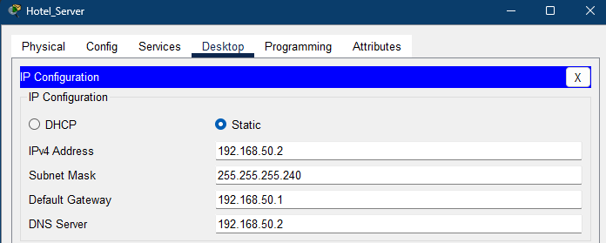
- Staff_Printer – to allow reliable printing from staff devices
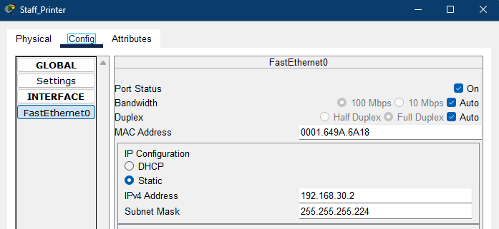

- Hotel_Router Serial Interface (Se0/1/0) – to establish a stable routed connection to the ISP
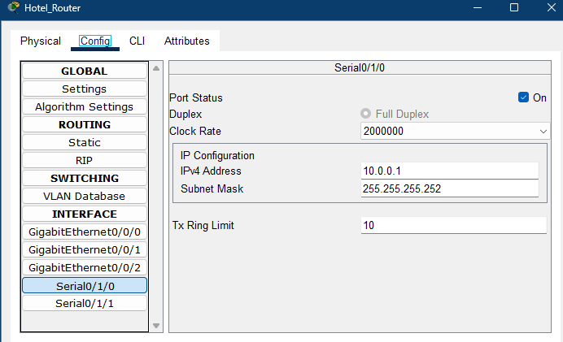
- ISP_Router Serial Interface (Se0/1/0) – to provide the corresponding point-to-point link with the hotel network
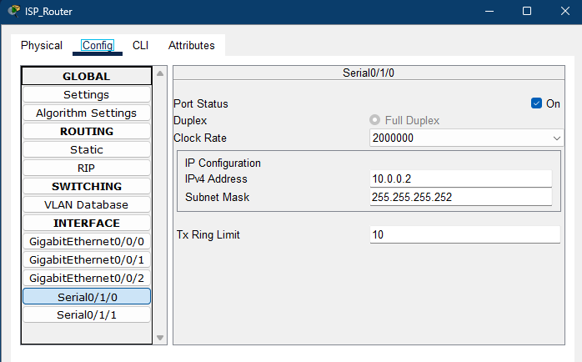
- ISP_Router Gigabit Interface (Gig0/0/0) – to serve as the default gateway for the external ISP network and ISP_Server
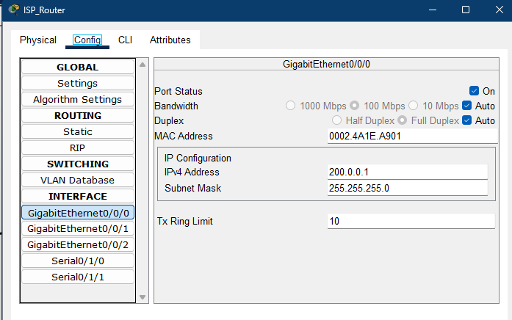
- ISP_Server – to represent a fixed external service
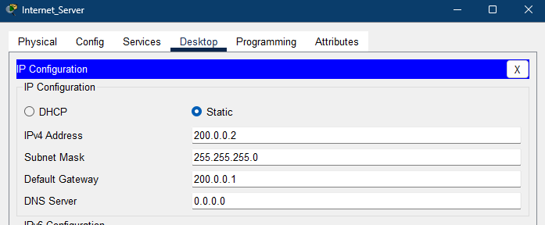
Static addressing on router interfaces ensures reliable routing, proper NAT operation, and consistent inter-network communication.

5. Network Configuration

5.1. VLAN Configuration on Switch
Virtual LANs (VLANs) were configured on the Hotel_Switch to logically separate network traffic for different hotel departments. Each VLAN corresponds to a specific department, allowing isolation at the data link layer while sharing the same physical switch infrastructure.
VLAN Creation:
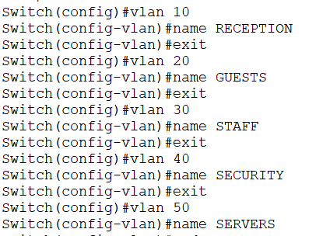
After VLAN creation, access ports were assigned to their respective VLANs based on the connected device type (e.g., reception PCs, staff devices, guest access point). This ensures that all devices belong to the correct broadcast domain.
Vlan 10 -> Fa0/2-3 (RECEPTION)
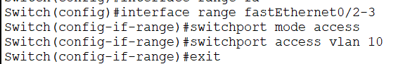
Vlan 20 -> fa0/9 (GUESTS)
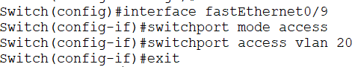
Vlan 30 -> fa0/4-6 (STAFF)
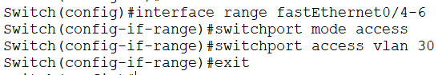
Vlan40 -> fa0/7 (SECURITY)
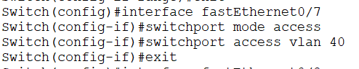
Vlan50 -> fa0/8 (SERVER)
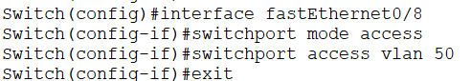
This configuration reduces broadcast traffic, improves security, and simplifies network management.

5.2. Trunk Configuration
To enable communication between multiple VLANs and the router, the link between the Hotel_Switch and the Hotel_Router was configured as a trunk port. Trunking allows traffic from all VLANs to traverse a single physical link using IEEE 802.1Q tagging.
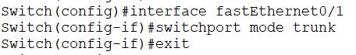
The trunk configuration ensures that VLAN-tagged frames reach the router correctly for inter-VLAN routing.

5.3. Inter-VLAN Routing (Router-on-a-Stick)
Inter-VLAN routing was implemented using the router-on-a-stick method. A single physical interface on the Hotel_Router was divided into multiple sub-interfaces, with each sub-interface assigned to a specific VLAN. This configuration allows controlled communication between VLANs while maintaining logical separation.
Each sub-interface was configured with:
- An IEEE 802.1Q encapsulation ID matching the VLAN number
- An IP address serving as the default gateway for that VLAN
For VLAN 10
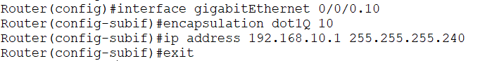
For VLAN 20
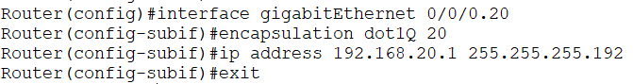
For VLAN 30
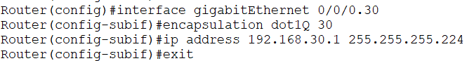
For VLAN 40
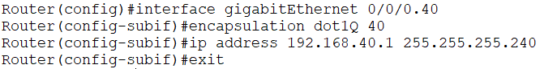
For VLAN 50
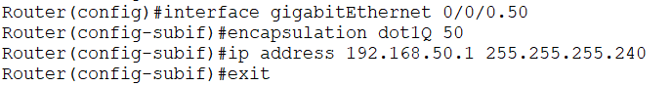

5.4. Routing Protocol Configuration
Multi-Area OSPF (Open Shortest Path First) was implemented to enable dynamic routing between the internal hotel network and the external ISP network.
The OSPF design uses three areas:
- Area 1: Represents the internal Hotel Network, including all VLAN subnets. This area contains departmental networks such as reception, guests, staff, security, and servers.
- Area 2: Represents the ISP Network, which includes the ISP router, switch, and ISP server.
- Area 0 (Backbone Area): Acts as the OSPF backbone and provides a transit path between Area 1 and Area 2. The serial link between the Hotel_Router and ISP_Router is placed in Area 0 to ensure proper inter-area routing.
Configuration on Hotel_Router:
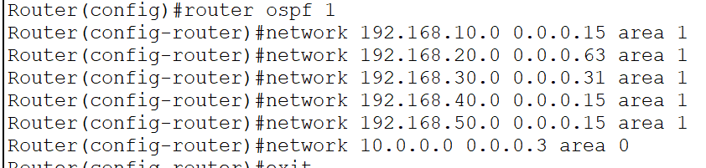
Configuration on ISP_Router
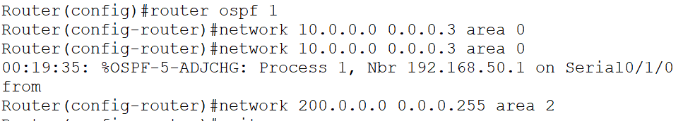

5.5. Static Routing as Backup
In addition to dynamic routing, static routes were configured as a backup mechanism to ensure network connectivity in case the OSPF routing process becomes unavailable.
To guarantee that OSPF remains the primary routing method, the Administrative Distance (AD) of the static routes was manually increased to 120. Since OSPF has a default administrative distance of 110, routes learned via OSPF are preferred under normal operating conditions.
Only if OSPF fails or its routes are removed from the routing table will the static routes (AD 120) be selected. This technique implements floating static routes, providing redundancy without interfering with dynamic routing.
On Hotel_Router: Static route to reach ISP network (200.0.0.0/24) via ISP_Router

On ISP_Router: Static route back to Hotel private networks (all VLANs: 192.168.10.0 – 192.168.50.0):
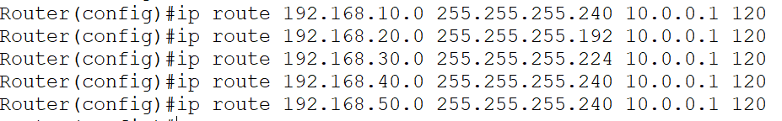

Routing table showing OSPF routes preferred over static routes due to lower administrative distance:
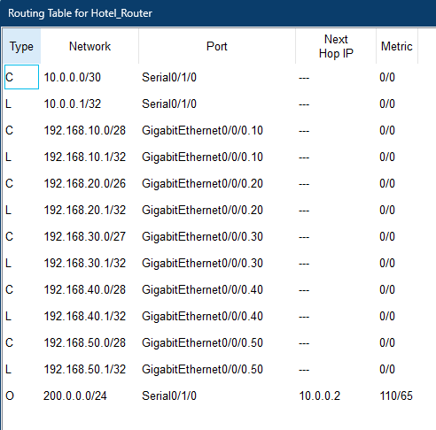
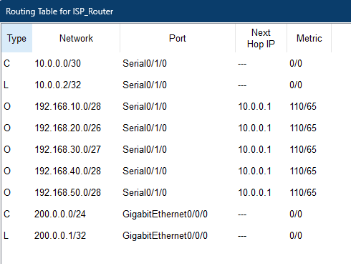
This hybrid approach combines the flexibility of dynamic routing with the reliability of static routes.

6. Security Implementation

6.1. VLAN-Based Isolation
VLAN-based isolation is the first layer of security implemented in the Smart Hotel Network. By assigning each department to a separate VLAN, devices are placed into different broadcast domains, even though they share the same physical switch infrastructure.
This isolation prevents unauthorized devices from directly accessing other departments and limits the spread of broadcast traffic. For example, guest devices connected to the Guests VLAN cannot directly communicate with staff, security, or server devices without explicit routing and permission.
VLAN-based segmentation therefore enhances security, improves performance, and provides a structured foundation for further access control mechanisms.

6.2. Access Control Lists (ACLs)
Access Control Lists (ACLs) were implemented to enforce security policies and control traffic flow within the Smart Hotel Network. Only two ACLs were used, each serving a distinct and specific purpose, following best practices for ACL deployment.

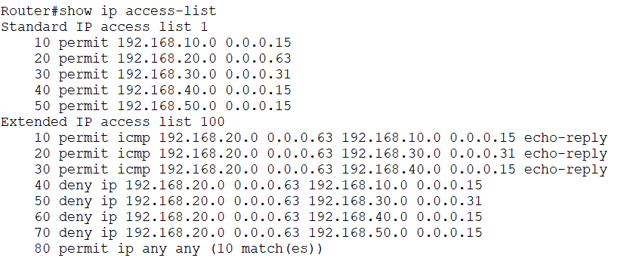

6.2.1 Standard ACL for NAT Control
A standard ACL was configured and used exclusively for Network Address Translation (NAT). This ACL defines which internal private IP networks are allowed to be translated when accessing external networks through the ISP.
The standard ACL matches source IP addresses of internal hotel subnets and is referenced by the NAT configuration. This ensures that only authorized internal networks can use NAT to reach external resources, such as the ISP server.
Using a standard ACL for NAT is appropriate, as only source address matching is required for this function.
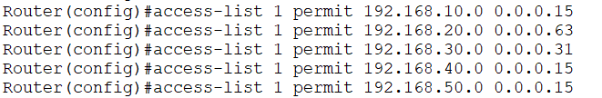

6.2.2 Extended ACL for Guest Network Restriction
An extended ACL was implemented to restrict access from the Guest VLAN (VLAN 20) to sensitive internal networks. This ACL explicitly:
- Denies traffic from the Guest VLAN to:
  - Staff VLAN
  - Security VLAN
  - Server VLAN
- Permits all other traffic, including access to the internet via the ISP
The ACL was applied inbound on the Guest VLAN router sub-interface, ensuring that unauthorized traffic is blocked at the earliest possible point, before it can traverse the internal network.
This placement minimizes unnecessary traffic flow, improves performance, and follows the recommended practice of placing extended ACLs as close to the source as possible.
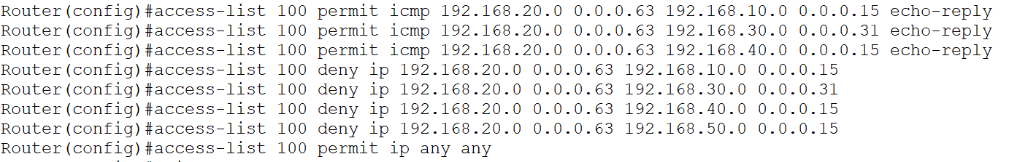
Apply ACL inbound on the Guest VLAN sub-interface
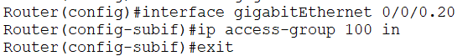

6.3. Network Address Translation (NAT)
Network Address Translation (NAT) was implemented to allow internal hotel devices to access external networks while preserving private IP addressing and maintaining network security.

NAT Overload (PAT)
NAT Overload, also known as Port Address Translation (PAT), was configured on the ISP-facing router interface. This allows multiple devices from private IP subnets to share a single public IP address when accessing external resources.
The NAT configuration followed these steps:
- Identify internal and external interfaces:
  - The router interface facing the hotel network was designated as inside.
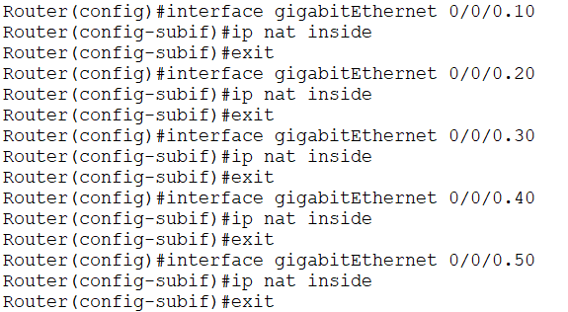
  - The interface connected to the ISP network was designated as outside.
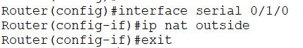
- Define the NAT pool or network to be translated:
  - A standard ACL was created to specify which internal subnets are allowed to be translated.
  - Only authorized VLANs (all except sensitive server or security subnets) were included.
- Apply NAT Overload (PAT):
  - NAT was configured to translate multiple private IPs to the single public IP of the ISP-facing interface using overloading.
  - This ensures that many internal devices can access external networks simultaneously without requiring multiple public IPs.
By following this process, NAT was implemented securely and efficiently, providing:
- IP address conservation for multiple internal devices
- Protection of internal network structure from external visibility
- Controlled access for guests and other VLAN devices to external services
This structured NAT configuration ensures secure, scalable, and controlled access to external networks from the hotel network.

6.4. DNS Configuration
A Domain Name System (DNS) was implemented to provide internal hostname resolution within the hotel network. DNS allows users and devices to reference critical infrastructure using human-readable names rather than numeric IP addresses, improving usability and reducing configuration errors.
In this network, DNS records were configured only for devices with static IP addresses, specifically:
- Hotel_Server – hosts internal services
- ISP_Server – represents external connectivity
- Staff_Printer – provides reliable printing services
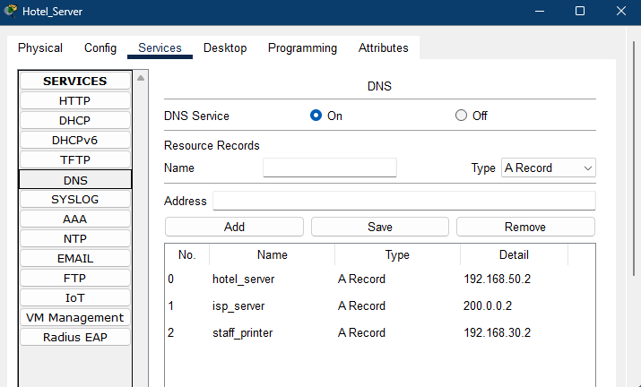

Reasoning for Limited DNS Entries
Only devices with static and predictable IP addresses were included because:
- Consistency: DNS entries must point to a fixed IP; dynamically assigned IPs could change, rendering the hostname invalid.
- Critical Services: These devices provide essential services that must be reliably reachable by other users or systems.
- Minimal Administrative Overhead: Limiting DNS to key infrastructure avoids unnecessary management of volatile client IPs (like guest devices).
This approach ensures that essential services remain easily accessible and identifiable while maintaining a manageable and stable DNS namespace.

7. Results and Testing
The testing phase verifies that the Smart Hotel Network operates as intended. Each component, VLANs, routing, DHCP, NAT, ACLs, and DNS, was systematically tested. The tests confirm both functional connectivity and security enforcement.

7.1. Connectivity Testing

Ping between devices within the same VLAN
Reception_PC1 to Reception_PC2
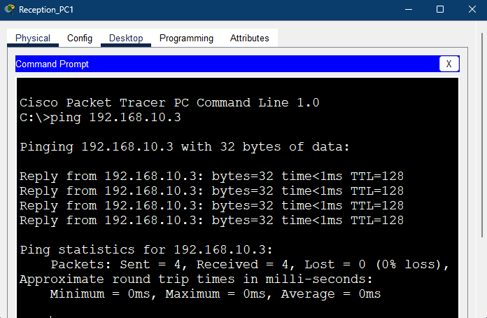

Ping between devices in different VLANs (inter-VLAN routing)
Staff_PC1 to Hotel_Server
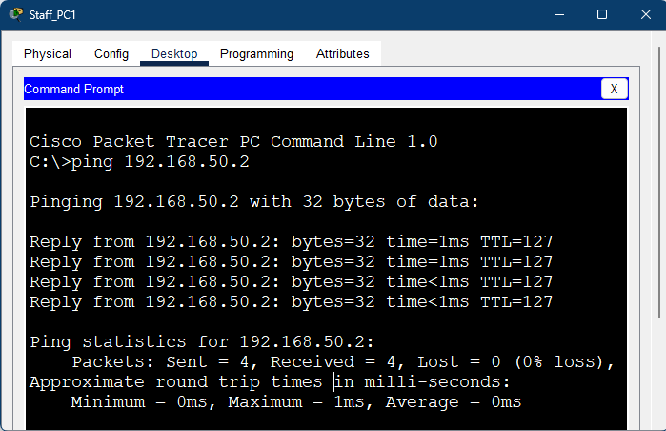

7.2. NAT Verification

Internal device accessing ISP_Server
Guest laptop2 to ISP_Server
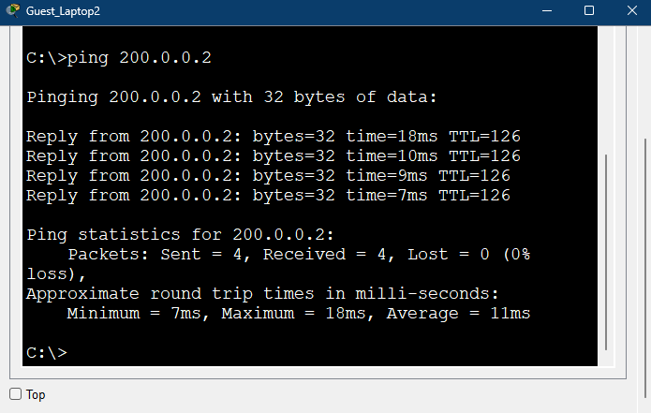

Verify NAT translations on router
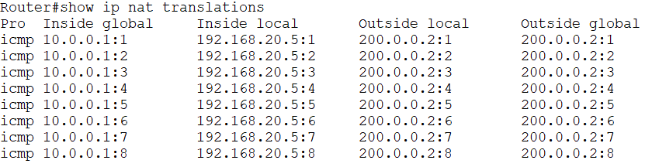

7.3. ACL Verification

Guest VLAN cannot access Staff, Security, or Server VLANs
Guest_Laptop3 to Staff_PC1
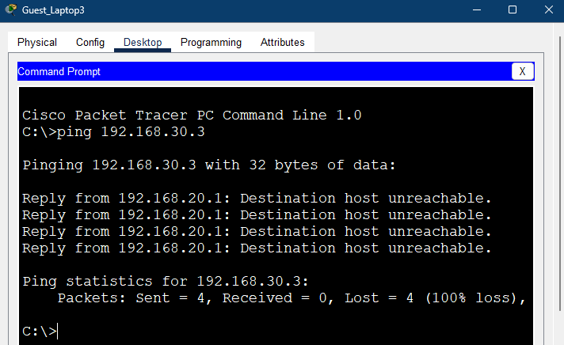

Guest VLAN can access external ISP server
Guest_Laptop1 → ISP_Server

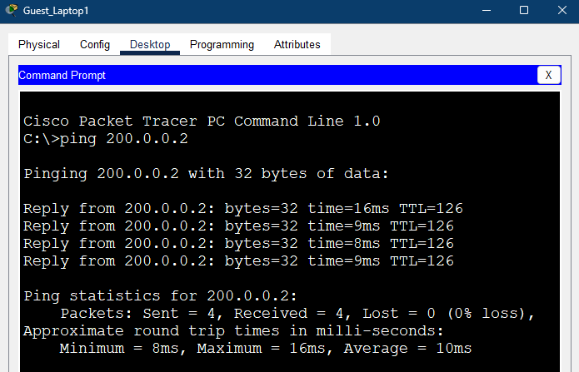

Reception, Staff, and Security VLANs can access Guest VLANs
Reception_PC1 → Guest_Phone1
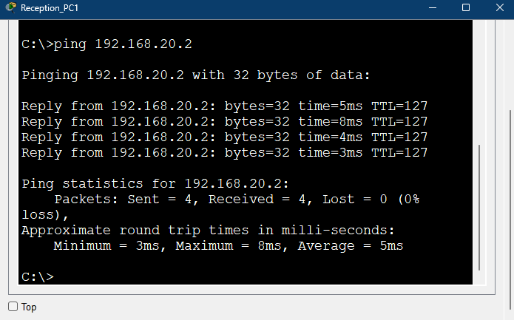

7.4. DNS Verification

Hostname resolution for hotel_server
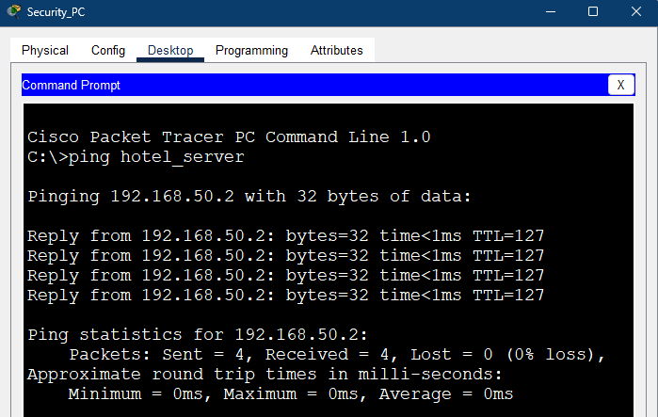

Hostname resolution for Staff_printer
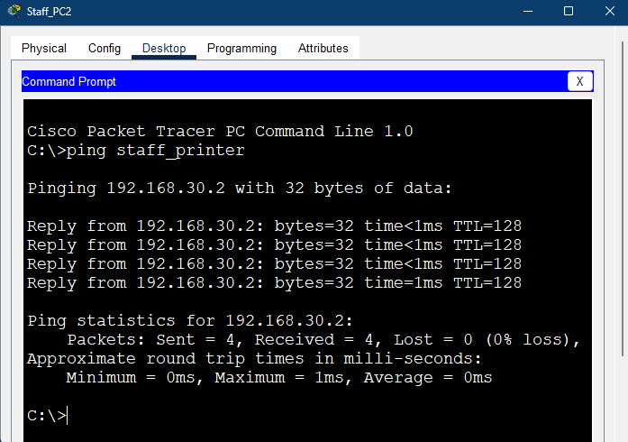

Hostname resolution for ISP_Server
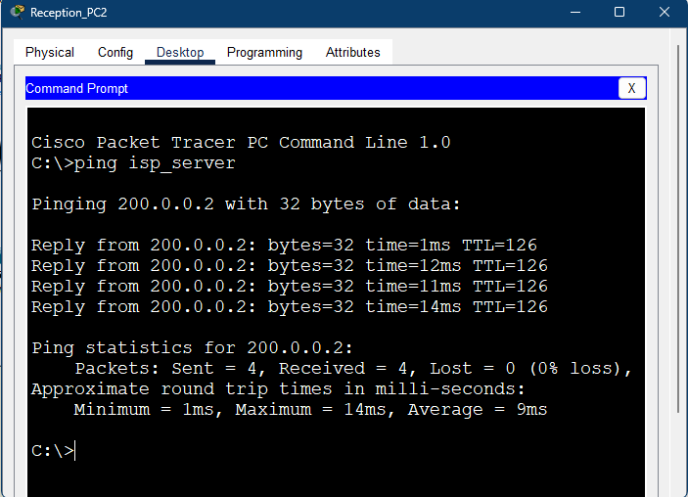

8. Conclusion

8.1. Summary of Implementation
The Smart Hotel Network project successfully demonstrates a fully segmented and functional network for a multi-department hotel environment. Key achievements include:
- VLAN-based segmentation of Reception, Guest, Staff, Security, and Server networks for improved security and traffic management.
- Inter-VLAN routing via router-on-a-stick configuration on the Hotel_Router, allowing controlled communication between authorized departments.
- Dynamic IP allocation for end-user devices via DHCP hosted on the Hotel_Server, while critical infrastructure devices (servers, printers, and router interfaces) were assigned static IP addresses.
- Multi-Area OSPF routing between the hotel network and ISP network, with floating static routes as a backup to ensure redundancy.
- Security mechanisms including ACLs to restrict guest access to sensitive VLANs, and NAT Overload (PAT) for controlled external connectivity.
- DNS implementation for key infrastructure devices, simplifying hostname resolution and internal service accessibility.
The network demonstrates scalable, secure, and reliable design practices suitable for a real-world hotel environment, while remaining fully functional within Cisco Packet Tracer.

8.2. Limitations
Despite the successful implementation of the Smart Hotel Network, certain limitations exist due to the simulation environment and simplified design choices:
- Single-router VLAN simulation: In the lab, all VLANs were configured on a single router for simplicity. In a real-world hotel network, each VLAN would typically be connected to its own switch, with the main switch handling inter-VLAN routing and aggregation. While this design simplifies testing, it does not fully replicate the physical distribution and potential traffic bottlenecks of a real network.
- Packet Tracer constraints: Advanced hardware features such as high availability protocols, redundant links, and true firewall rules cannot be fully simulated.
- Simplified ISP network: The external network was represented by a single ISP router and server, which limits testing of large-scale routing and NAT scenarios.
- Limited wireless security: Guest access points were configured for connectivity only; advanced wireless encryption standards (e.g., WPA2-Enterprise) were not implemented.
- No real failover testing: Physical link redundancy and hardware failures could not be fully tested in the simulator.

8.3. Future Improvements
The network can be extended and improved in the following ways:
- Enhanced wireless security: Implement WPA2-Enterprise or WPA3 on guest APs for stronger authentication and encryption.
- Advanced firewall rules: Deploy hardware or software firewalls to filter traffic more granularly and protect critical systems.
- Load balancing: Introduce multiple servers and distribute traffic to improve performance and reliability.
- Redundant links and high availability: Add backup links between switches and routers to minimize downtime and provide automatic failover.
- Network monitoring and logging: Implement SNMP-based monitoring or centralized logging to proactively detect network issues.

